1. **Introduction - Rye**

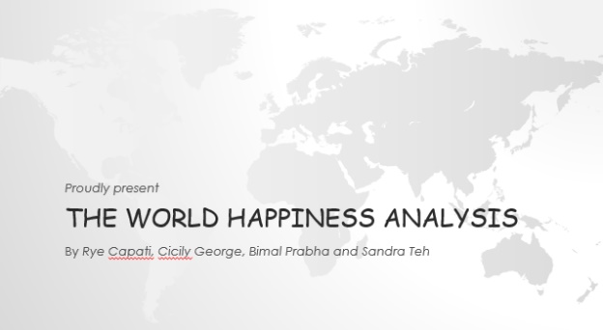

Good evening everyone! We are the Merry Team. We have Bimal, Cicily, Sandra Teh and me myself Rye in the team.

Tonight, we are going to present “The World Happiness Analysis”. First, we would like to talk about our data before we go into analysis.

1. **Jupternote book - Rye**

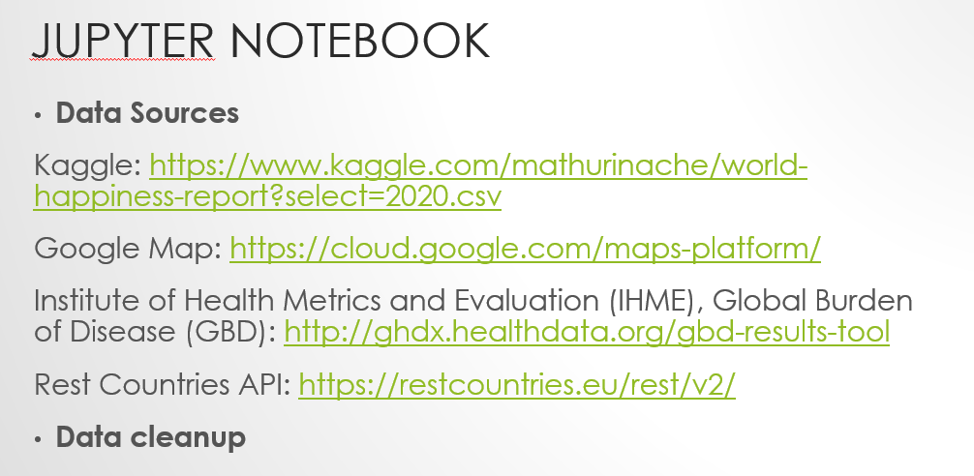

In this slide, you can see that we got our data from Kaggle, Google Map, IHME and Rest Countries API.

Before we get into any analysis, we started with analysing the data and cleaning up the data.

For instance, we go through the column name of the tables to make sure that the column names are consistent across all the tables. If they are not, we renamed the column names. We also make sure those column names are removed if they are not needed. We looked at the data to ensure that if there is NaaN value, we either replace it with something or we remove it completely. Before removing any data, we also make sure that the NaaN value is not going to impact our analysis. Also, we looked at the consistency of the data in all the tables to make sure that those data are related. once we have cleaned up the data, we then merged the data together using concatenate function. The reason why we chose to use the concatenate function instead of groudby is because we find that it will be easier to do data visualisation and analysis. We do notice that concatenate function is going take up more memory but given the data size we have; concatenate function was not an issue in our analysis. we mainly use Plotly and Seaborn to do our data visualisation.

1. **The world Happiness Analysis - Rye**



Let’s get into the interesting part now. The world Happiness Analysis.

1. **How happy we are compared to the world? -Rye**

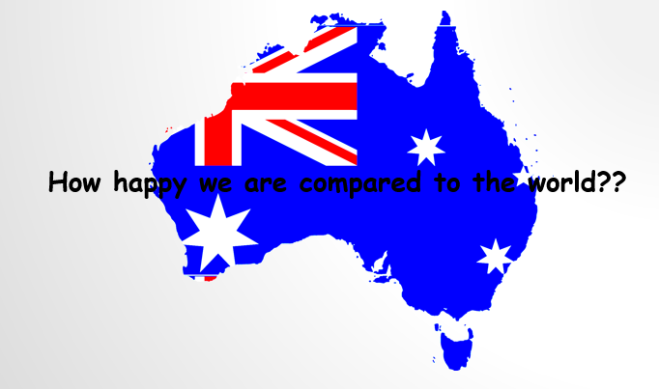

Before we start talking about our analysis, I would like to ask everyone, how happy we are compared to the world?? (Stop for 3 mins)

1. **Australia Ranking 2015 to 2019 – Rye**

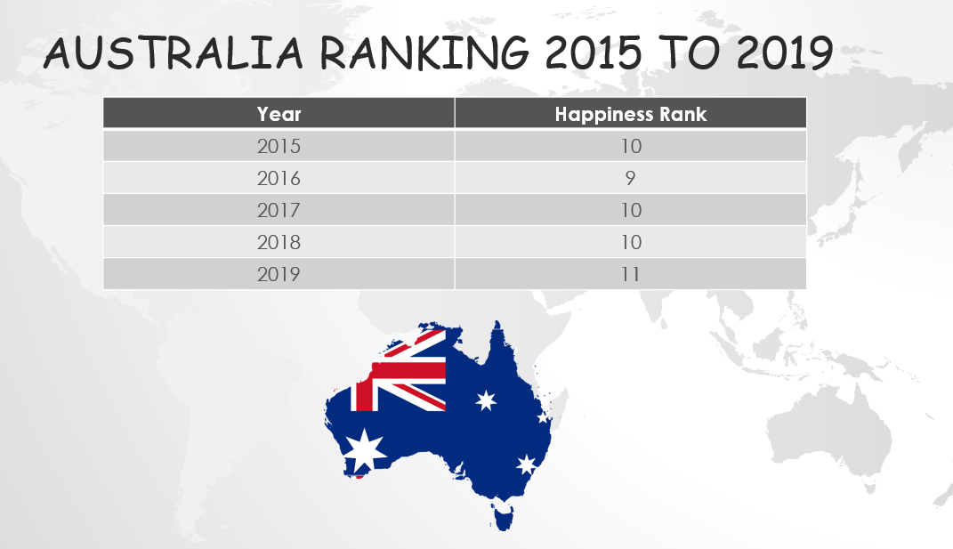

Ta da… As you can see from the slide, Australia rank 10 in 2015, 9 in 2016, 10 in 2017 again 10 in 2018 and 11 in 2019. I am sure the result did not surprise everyone; we are indeed living in a happy country.

1. **7 factors that determine the happiness score - Rye**

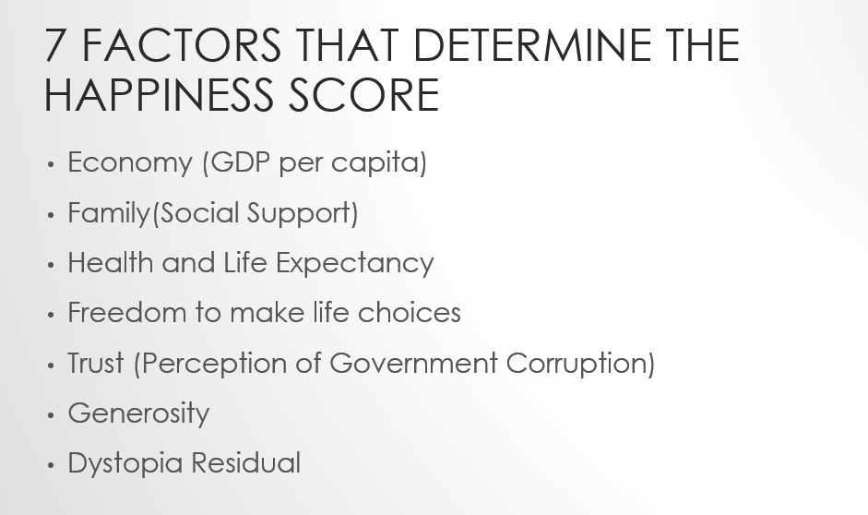

What are the factors that determine the happiness score? As you can see from the slide, these are the 7 factors that determine the happiness score.

**Economy** – this shows the prosperity of a country based on its economic growth.

**Family** – this shows the support each family or person is getting within the country

**Health** – this shows the health wellbeing & life expectancy within the country

**Freedom to make life choices** – this shows the free we are within the country

**Trust** – how people perceive their government

**Generosity** – generosity of the people within the country. (eg. Nearly half of all people in Finland give money back to charity regularly and one-third of the Finish population volunteers their time.)

**Dystopia** – is an imaginary country that has the world’s least-happy people. The purpose in establishing Dystopia is to have a benchmark against which all countries can be favourably compared (no country performs more poorly than Dystopia) in terms of each of the six factors.

1. **The top 10 countries and the bottom 10 countries. - Bimal**



Since we know that Australia is a happy country, we thought that it would be interesting to see what the top 10 countries and bottom 10 countries are looks like.

1. **The top 10 countries and the bottom 10 countries - Bimal**

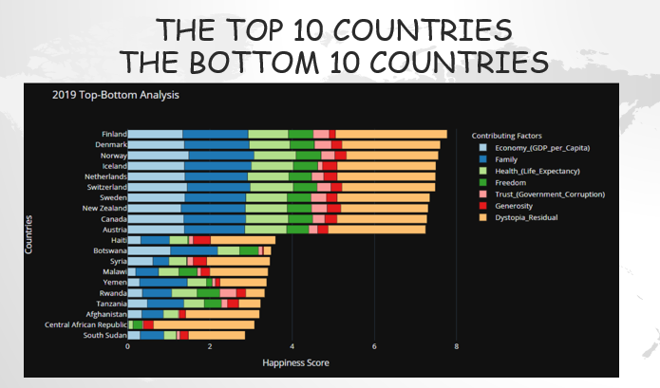

This is a bar graph that showing the top 10 countries and bottom 10 countries and the score of each factor in Year 2019. The first 10 bars showing the top 10 countries and the bottom 10 bars showing bottom 10 countries. In general, we can see that GDP is usually high in top 10 countries and low in bottom 10 countries. Generosity is almost on par with the top 10 countries. As we observe from the bar graph, the family value is almost same as the top ranked countries.

1. **Year 2015 to Year 2019 - Bimal**

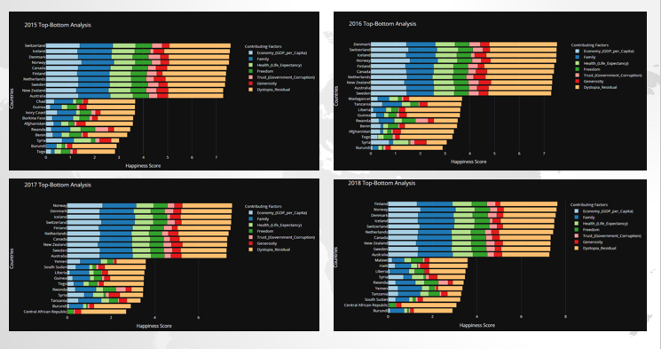

These are the bar graphs that showing from year 2015 to 2018. Now seeing these changes, we tried to dig deeper we wanted to know is there any factors which significantly improved or regressed the score?

1. **Are those factors correlated? – Bimal**



1. **Heatmap – Bimal**

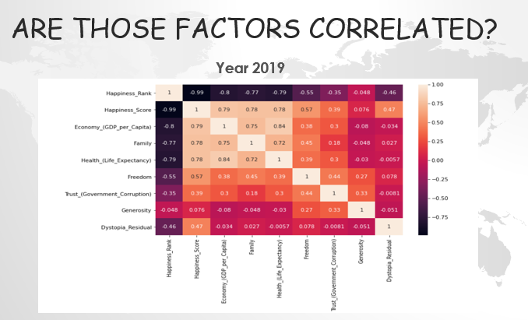

In this heatmap graph, it is showing the correlation between each factor. As we all know the higher the value, the better the correlation is. If we look at those value that above 0.7, we can see that GDP per capita are highly correlated to Happiness Score. Following by Family and Health Life Expectancy. If we look at the GDP per capita, we also can see that the correlation between GDP per capital, family and health life expectancy are highly correlated as well. I guess this is kind of make sense to us. As the income is higher, your expectancy of health life will increase as well. Again, as previously mention, we can see the generosity is not correlated to GDP per capita as well. Another trend you can observe here, It’s easy to identify what lacking the bottom ranked countries but what s interesting even though economic GDP, people haven’t lost hope and family factor is on same par as the top countries.

1. **Year 2016 to Year 2018 – Bimal**

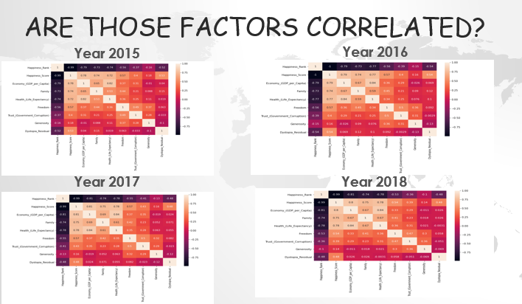

1. **Changes over the year for the 7 primary factors. – Bimal will give another graph**
2. **The Top 10 countries and from year 2015 to 2019 – Cicily**

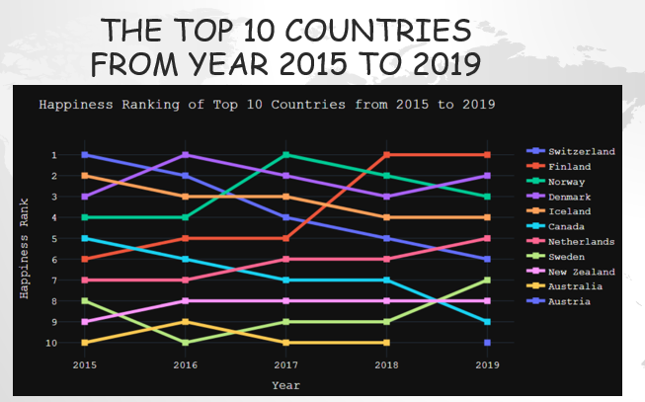

After we analyse the factors, we thought it would be interesting to see whether the top 10 countries stay consistent over the year. From this graph, we notice in Year 2015, the top country is Switzerland but it is kind of drop over the year, in Year 2019 Switzerland drop to 6. Another interesting one is Finland, it was only 6 in Year 2015 but it gone up to number 1 in Year 2018 to 2019. Overall, the top 10 countries stay consistent on top 10 over the year. Looking at where we live, Australia always on the top 10 countries from Year 2015 to 2018. However, it replaced by Austria in Year 2019. Saying that, that doesn’t mean that we are not happy anymore as we are still ranked at 11 in Year 2020. Also, even though GDP was par with top country we came to realise what pull down was increase in corruption.

1. **Top 10 Countries By Region – Sandra**



Another question we think would be very interesting is to see which region has the top 10 countries and bottom 10 countries. If we look at the top 10 countries. The colour bubbles on this map represents the top 10 countries and the colour indicate their happiness score. The top 10 countries happiness score is between 7 to 8. The yellow represents the higher score, the blue represents lower score.

In Year 2019, we can see that the top 10 countries are on the Europe region. If we look at 2015 to 2019. Interestingly, most of the top 10 countries are on the Europe region as well which is consistent over the years.

As we can see from the map, Australia was on the top 10 from year 2015 to year 2018. However, Australia ranking drop to 11 in year 2019. Australia still considered a happy country overall compared to 156 countries.

1. **Bottom 10 Countries by Region – Sandra**



Again, the colour bubbles on this map represents the bottom 10 countries and the colour indicate their happiness score. The bottom 10 countries happiness score is between 2 to 4. Again, the yellow represents the higher score, the blue represents lower score.

If we are scrolling from Year 2015 to 2019, we can see most of the bottom 10 countries are on the Africa, Middle East region which is interesting as well.

1. **Australia VS Top 1 Country (2019) - Sandra**

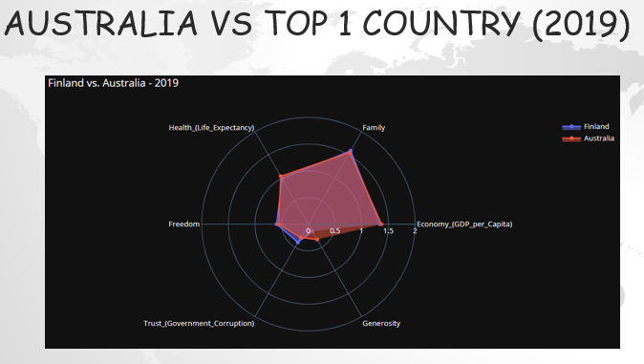

Comparing Australia to Top 1 country in 2019 in this graph, the red one is Australia and the blue one is Finland. As we can see our score are very close to the Top 1 country. Australia score in Family, Freedom, Trust is slightly lower than Finland but Australia score in GDP per capital and Generosity is slightly higher than Finland

1. **Australia VS Top 1 Country (2015) - Sandra**

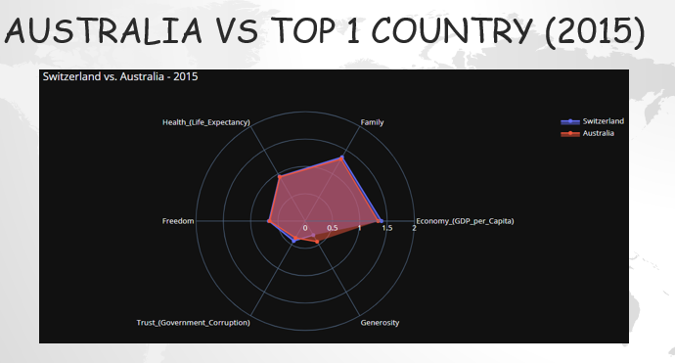

Analysing Year 2015, the only score that higher than the top 1 country which is Switzerland is Generosity but the rest of the factor are lower then Switzerland.

1. **Prediction – Rye**



Based on our rankings from the 2015 to 2019, we’ve made some predictions on the happiness score of Australia along with the predicted happiness score of the top 10th country (meaning the minimum score to get into the top 10)

to see if we will make it to the top 10.

Our data is consistent throughout the years for Australia’s ranking so checking the normality of the data was not necessary.

1. **Prediction – Rye**

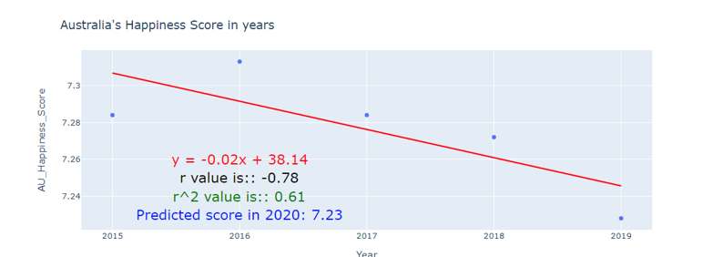

As you can see, we have a negative correlation. Australia’s score goes down as the year progress with a predicted score of 7.23.

1. **Prediction – Rye**

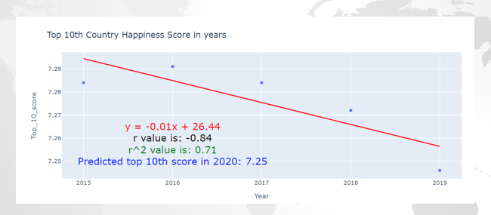

The score of the top 10th country also shows a negative correlation.

But Australia’s score does not meet the minimum score to make it to the top 10 which is 7.25

1. **Bonus – Cicily**

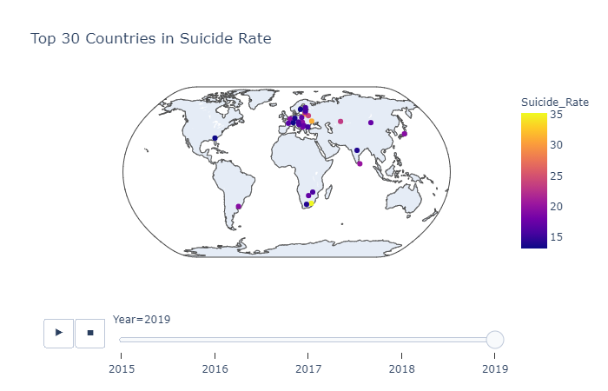

As a Bonus part, like we do in the Bootcamp activities, we found something which seems contradicting.

The map above shows the Top 30 Countries in Suicide rate, we can see most of the European countries are there in the top, which are the happy countries. We have already established that European countries are happiest countries in the world. Simultaneously they have highest suicide rates among other countries.

But, there is no evidence which shows that the countries with higher happiness score will have high suicide rate. And Australia is not there, which is good.

1. **Bonus – Cicily**

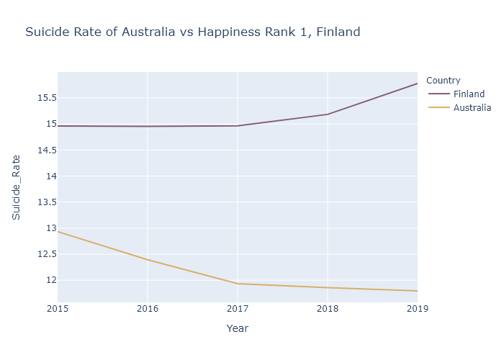

The lack of any clear relation between suicide and happiness remains unresolved. It is because suicide is hard to explain. It is silly to think that a single number like “happiness score” could completely explain something as complex as human happiness, but when the score that is meant to be representative of happiness and quality of life strongly correlates with suicide something is very wrong.

Finland is an example of a country with a high happiness score and high suicide rate. Australia's suicide rate is lesser than, most of the European nations. Though Australia's suicide rate is lesser than, most of the European nations, our genrosity is higher than the top country and family values are on par with rank no. 1 So give a pat on your back for being kind and give a hug to your family

1. **Conclusion – Cicily**

This analysis illustrated that the world’s happiest countries are primarily in North Western Europe, North America, and Australia & New Zealand. It also revealed that Economy (GDP per capita) is the most important factor in evaluating a country’s happiness. Unsurprisingly, the happiest countries and world regions generally tended to be ones with strong and stable economies. The importance of Economy is also strongly positively correlated with those of Family and Health. This is expected, since more economic stability and higher GDP per capita generally encourages stable and comfortable family life as well as increases the availability of proper medical resources and healthcare. These factors then weigh more when determining overall happiness.

1. **Information: - Cicily**

If you need more infroamtion, you can visit this website to find out more.

1. **Jupter notebook – Everyone**